Ecumenical and Interreligious Dialogue of Action
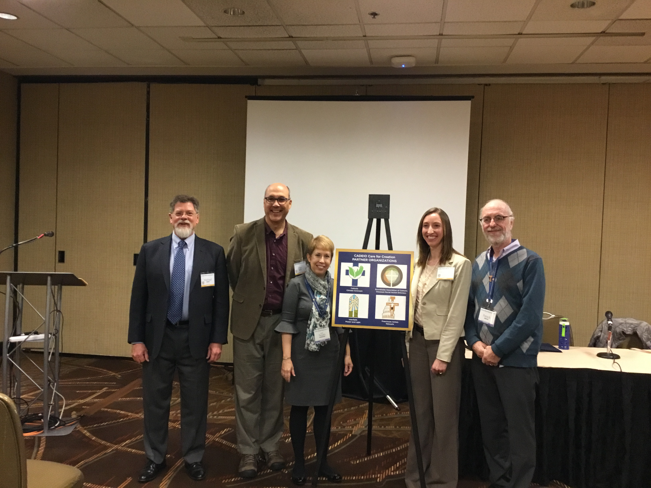
to Care for Our Common Home
Catholic Association of Diocesan Ecumenical and Interreligious Officers’ (CADEIO) Care for Creation partner organizations are introduced at the 2019 National Workshop for Christian Unity. Left to right: Michael Terrien, Chair, CADEIO Care for Creation Committee; Dan Misleh, Executive Director, Catholic Climate Covenant; Susan Hendershot, President, Interfaith Power and Light; Catherine Orr, Trustee and Coordinator, Roundtable Association of Catholic Diocesan Social Action Directors; Patrick Carolan, Executive Director, Franciscan Action Network

April 2 - 3, 2019

St. Louis, Mo. The Catholic Association of Diocesan Ecumenical and Interreligious Officers (CADEIO) introduced its Care for Creation partner organizations and portal to attendees at the National Workshop Christian Unity. Over seventy-five people from different churches throughout the United States attended the two sessions, which focused on the Catholic Church’s call for ecumenical and interreligious dialogue of action to care for our common home.

The April 2 session highlighted the importance for Christians and people of all faiths to engage in caring for creation as a means to build Christian unity and interreligious harmony. The session also highlighted the importance of caring for, protecting and preserving God’s creation now and for generations to come. It recognized that the exploitation of creation is a sin and the need for humanity to convert our relationship with each other and creation for the sake of the common good.

During the April 2 session, CADEIO’s Care for Creation web-based portal, creation.cadeio.org, was introduced to attendees. The portal is designed to support CADEIO members and associate members in implementing ecumenical and interreligious dialogues of action to care for creation within their dioceses.

The portal will provide the following benefits:

- Serves CADEIO members and their constituents by informing them about and involving them in US Catholic ecumenical and interreligious care for creation news & events;
- Provides the capacity to include all Catholic stakeholders within each diocese;
- Drives attendance and participation in diocesan events;
- Provides a directory of diocesan officers and other stakeholders;
- Documents and archives events and news;
- Is safe and protected;
- Gives officers control of how the system is used within their diocese;
- Provides ongoing programmatic and technical support via CADIEO Committee and partner organizations; and
- Builds a learning community to support each other in carrying out work.

On April 3, session participants were introduced to CADEIO’s four Care for Creation partner organizations: The Catholic Climate Covenant, The Roundtable Association of Catholic Diocesan Social Action Directors, Franciscan Action Network, and Interfaith Power and Light. Partner organization executives introduced their agencies’ purposes, and how the organizations can support CADEIO’s members and associate members in implementing their ecumenical and interreligious dialogues to care for creation in dioceses throughout the United States.

For further information or to receive support to register or subscribe to CADEIO’s care for creation portal, creation.cadeio.org, contact Amanda Bielat, abielat@student.ctu.edu

###

